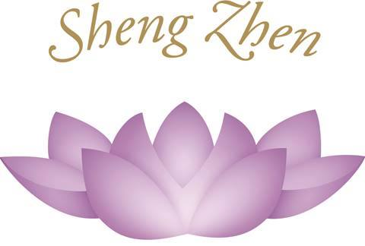

Sheng Zhen Self-Healing Retreat

Heaven Earth Heart Mantra
Jing Li
March 19 - 21, 2020
Notre Dame de Sion, Ein Kerem,
Jerusalem
Israel
Sheng Zhen Meditation
Quiet the Heart and Mind, relax the Body, be one with Nature!
Be one with the power of Love!
We shall primarily focus on the form of 'Heaven Earth Heart Mantra', and additionally, we shall do some standing practice.
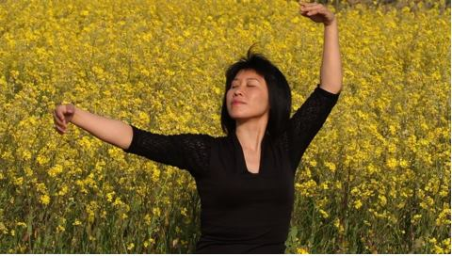
Date & Time: The program begins Thursday March 19th at 10:00 and ends on Saturday March 21 at 17:00.
Program: • Sheng Zhen Meditation –Heaven Earth Heart Mantra
• Heart-Mind power in self-healing
Location: Notre Dame de Sion Ein Kerem‏, Jerusalem, Israel.
The Monastery is a beautiful, quiet place.
Upon entering the grounds of Notre de Dame de Sion, one is immediately entering a sanctuary of peace, quiet, meditative reflection and serenity.
Airport: Ben Gurion Airport, Tel Aviv. (Notre Dame de Sion Ein Kerem is a 30-minutes drive from the Airport.
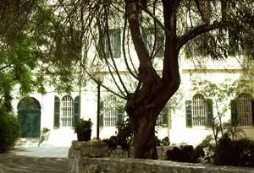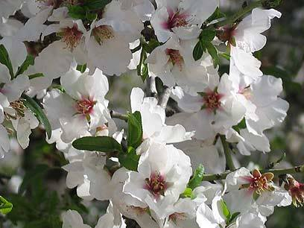

For more Details & to Register: dina.shafrir@gmail.com
+972-52-2332390
I would like to sign up:

1. My Name
2. Country I am from
3. My E-mail
4. My phone number

With love,
Sheng Zhen Meditation Israel

